NAME: KARTHIGA G SLOT: A
REG NO:192421383 SUB: CLOUD COMPUTING
EXP 3: PROPERTY BUYING & RENTAL SYSTEM (SaaS – CHENNAI)
AIM
To develop a Property Buying & Rental System for Chennai city and deploy it as SaaS using Zoho Creator.

ALGORITHM
- Start
- Login to Zoho Creator
- Create application
- Create property form
- Add property details
- Create report
- Run application
- Enter property data
- Display property listings
- Share application link
- Stop

PROCEDURE
- Create application (PropertyRentalApp)
- Create form (PropertyForm)
- Add fields: Owner Name, Contact, Property Type, Purpose, Location (Chennai), Price, Bedrooms, Date, Email
- Create report (PropertyReport)
- Run application and enter data
- View property details in report
- Share application link
OUTPUT SCREENSHOT
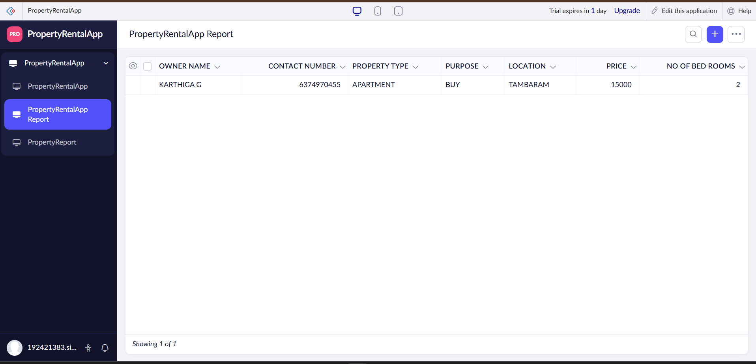
RESULT:
A Property Buying & Rental System for Chennai city was successfully developed and deployed as SaaS using Zoho Creator.

